Exercise 2 in Advanced SQL (INDEXES):
-- Exercise 1: Non-Clustered Index
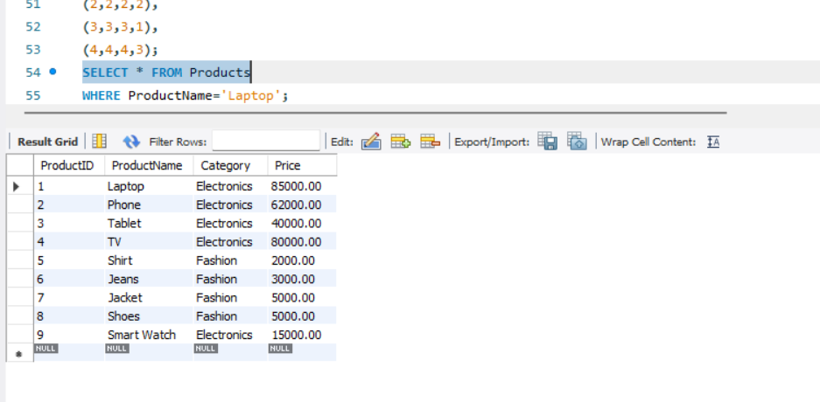

-- Exercise 2: Index on OrderDate
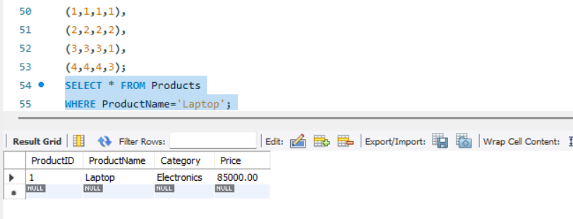
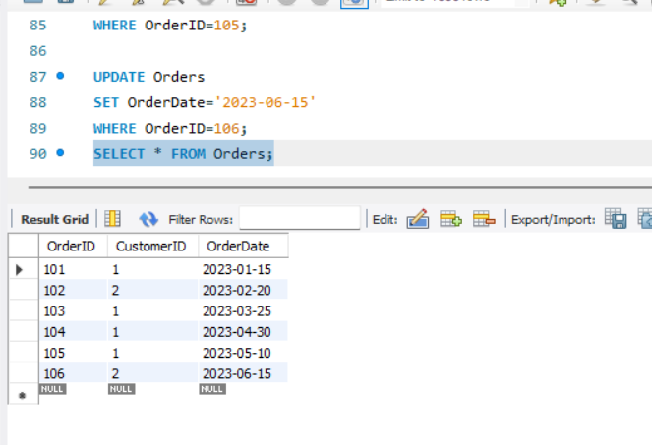

-- Exercise 3: Composite Index
